8
Using Deep Learning to Detect Apple Leaf Disease

Syed Nisar Hussain Bukhari, Rukaya Manzoor, Ummer Iqbal, and Muneer Ahmad Dar
National Institute of Electronics and Information Technology (NIELIT), Srinagar, India

INTRODUCTION
Kashmir, land rich in its culture and languages, is also rich in its vegeta- tion. Its soil supports the growth of a variety of fruits, the apple being the most famous. Apple production brings in a lot of wealth. The apple tree originated in central Asia and is now cultivated worldwide. Its botanical name is malus domestica [1]. In Kashmir, a wide variety of apples are cul- tivated viz Delicious, Golden, Ambri, Chamboora, etc. Apples are grown in almost every district of Kashmir and generate annual revenue of Rs. 1500 crores [2]. The apple tree is, however, vulnerable to certain kinds of disease, which affect its leaves. The typical apple leaf diseases found in Kashmir are Alternaria leaf blotch, apple scab, and apple rot, as shown in Figure 8.1. These diseases render the whole orchard devastated, which is a big challenge for the farmers. These diseases damage the quality and decrease the quantity of crops. The traditional ways to diagnose the dis- ease cause greater damage, as the methods are slow, labor-intensive, and nonreliable. These methods need experts with extensive knowledge and experience and are often inaccurate. The pesticide that is then used is also improper and becomes an economic and environmental burden.
Now it has become the need of the hour to change the traditional time- consuming methods to novel technology-based methods. The advanced technology has put machine learning in use, which automatically detects and classifies the disease of apple leaves. However, this method has a

142 DOI: 10.1201/9781003485179-8

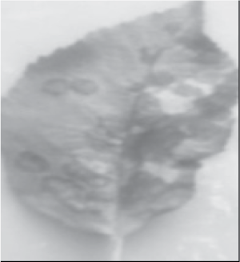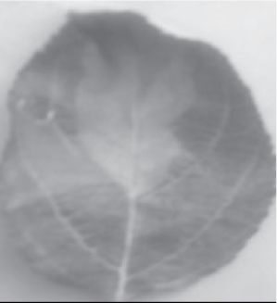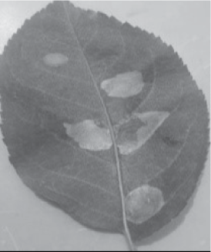
(a) (b) (c)

FIGURE 8.1
Typical apple diseases: (a) Alternaria leaf blotch, (b) apple scab, and (c) apple rot.

drawback, as it cannot be applied to raw data and requires preprocessing. Deep learning has now emerged as a better alternative, as it can be applied to raw data, and no extra step of preprocessing is needed. Further advancements in deep learning have led to the idea of a convolution neu- ral network (CNN). It is particularly used for image classification. CNN comprises two components – viz, convolution and pooling used for fea- ture extraction, and the classifier component, which predicts the output. In this study, various versions of CNN algorithms have been used for pre- dicting and classifying different types of disease in apple leaves.
This chapter contains four sections. The first section is about related work done in related fields. The second section talks about experimental details. This section includes methods, model building, data set, and experimental environment. The third section is about analyzing the results using different performance evaluation metrics. The last section sums up the conclusion of the study.

RELATED WORK
Deep learning and machine learning techniques have been practiced on different disease predictions on different types of agricultural products. The research related to the identification and classification of plant leaf diseases is presented in this section. The remainder of this section gives a detailed explanation of the research undertaken in this field. The sum- marization of this section is given in Table 8.1.
Zhang et al. [3] introduced a new method of apple leaf disease identifica- tion. The model was based on the support vector machine (SVM) classifier. The dataset for the identification of diseased apple leaves contains 90

TABLE 8.1
Related Work Done in Related Fields

Author Year Description Algorithm

Classification Accuracy (%)

Zhang et al. [3] 2017 Identification of apple
leaf diseases
Dubey et al. [4] 2012 Identification and
categorization of apple fruit disease
Arivazhagan | 2013 | Detection and | SVM | 94
et al. [5] |  | classification of leaf
 |  | disease
Brahimi et al. [6] | 2017 | Recognition of tomato | CNN | 99
 |  | leaf diseases
Khan et al. [7] | 2021 | Classification and | CNN | 97.18
 |  | identification of

SVM 90
SVM 93

apple diseases
Jan et al. [8] 2020 Apple disease diagnosis
for predicting apple scab and leaf/spot blight disease

MLP 99.1

images of healthy apple leaves, mosaic leaf, powdery mildew leaves, and rust leaves. This approach acquired an identification accuracy of more than 90%. S. R. Dubey et al. [4] developed a system for the detection and classification of apple fruit disease. In this system, image segmentation was done using K means clustering. The segmented images were then used to obtain the art features. Finally, the images are classified into apple blotch, apple rot, and apple scab using multiclass SVM. This model achieved an accuracy of 93%. Arivazhagan et al. [5] developed a software- based automatic recognition and classification of plant leaf disease. For the processing part, color conversion and segmentation were applied to images. The system used an SVM classifier for recognition and classifica- tion. An accuracy of 94% was achieved. Brahimi et al. [6] also applied a deep-learning (CNN algorithm) model for a similar study classifying tomato disease. The model used leaf images and achieved a classification accuracy of 99%. Khan et al. [7] used the concept of CNN to perform feature extraction from leaf images. The CNN model worked to predict the diseased leaves and acquired an accuracy of about 97%. Jan et al. [8] developed an outstanding apple disease recognition system to recognize leaf/spot blight and apple scab disease. The proposed system used

shape-based and low-level features of leaves to train a multilayer percep- tion (MLP) model. The model achieves an accuracy of 99.1%.

PROPOSED METHODOLOGY
The methodology employed in this study is a structured approach designed to comprehensively address the challenges of predicting and classifying apple leaf diseases. These steps encompass acquiring an image dataset, performing image preprocessing, constructing a predictive model, evalu- ating the model’s performance, and analyzing the results. The methodol- ogy is shown in the following flow chart (Figure 8.2).

Methods
The study has been conducted using a custom CNN, VGG 16, ResNet-50 and Inception V3. The pretrained networks VGG 16, ResNet-50, and Inception V3 are all powered by convolution neural techniques. The work- ing of CNN, along with its mathematical modeling, is explained next.
CNN is a type of deep-learning algorithm that is mostly used for image classification [9]. The architecture of CNN contains many layers, and each layer performs a different function. The layers of CNN are connected to each other, and the output of a layer is input for the next layer [10]. Mainly, there are three layers in CNN – namely, the convolution layer, pooling layer, and fully connected layer.

      - Convolution Layer
The convolution layer is a key layer in CNN, whose function is feature extraction [11]. Feature extraction is done by using a filter or kernel. In the convolution layer, an activation/feature map is formed by the convolution operation between the input image and the kernel.
Equation 8.1 represents the convolution operation mathematically.

⎛ n ⎞

O_{j} = f ⎜ ∑a_{i} ∗ k_{i,} _{j} + b_{j} ⎟
(8.1)

⎜ ⎟
⎝ i =1 ⎠

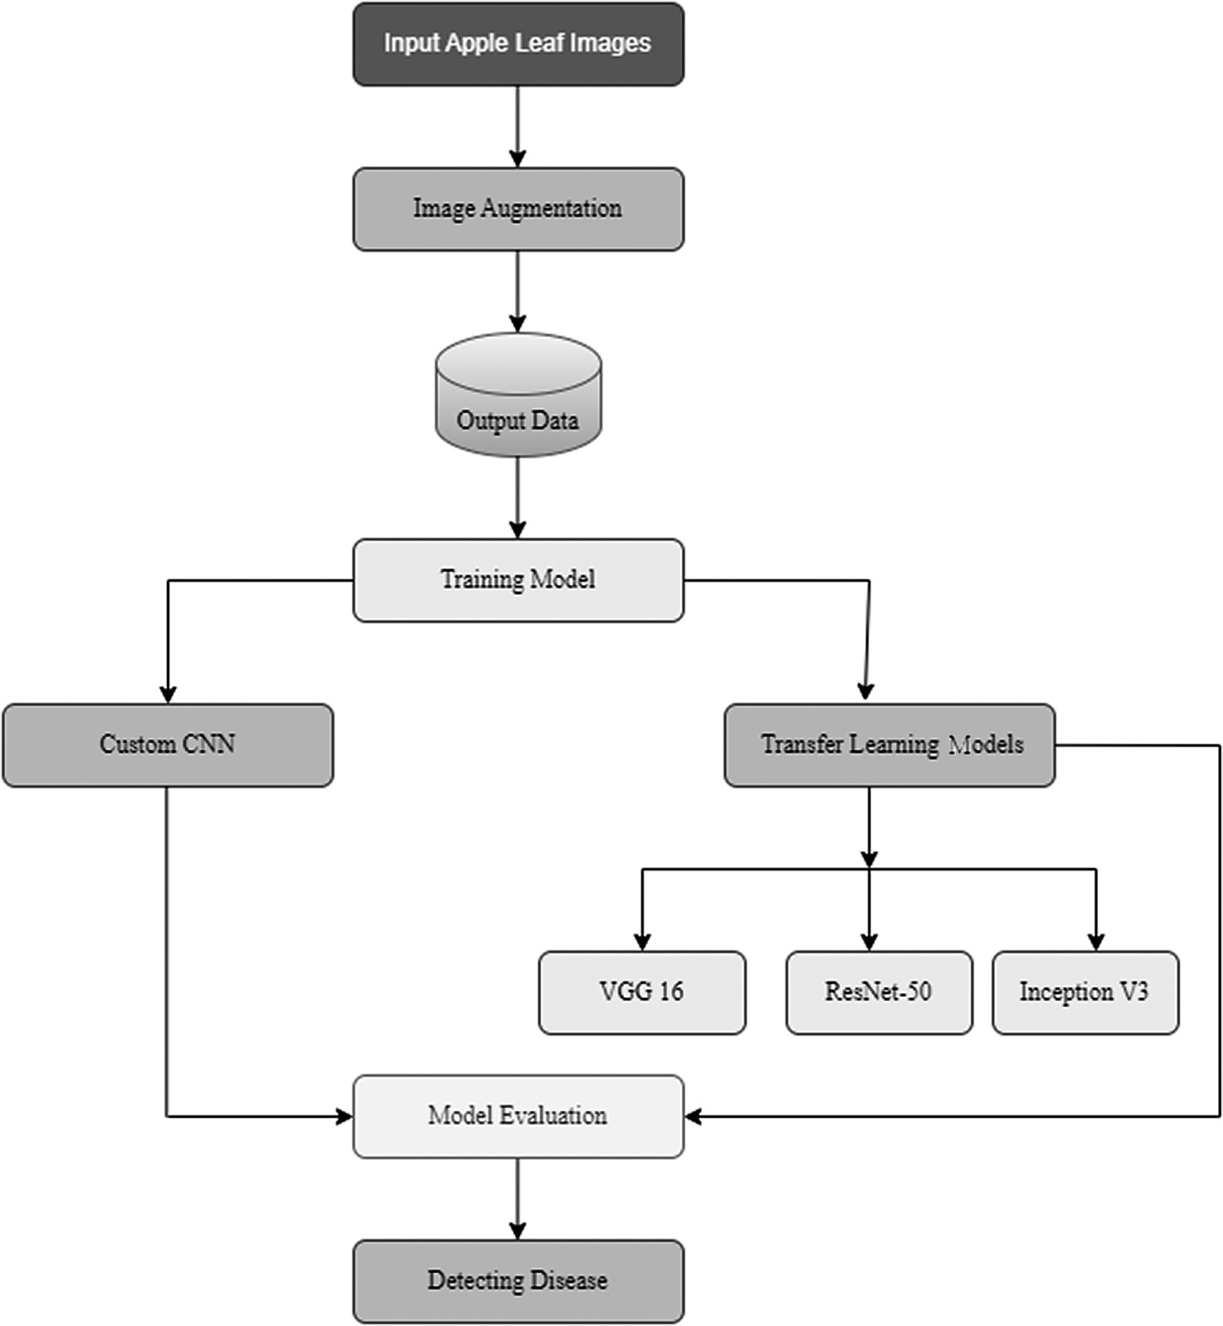

FIGURE 8.2
Methodological steps.

First of all, the input image a_{i} is convoluted with the kernel k_{i,} _{j}; then the summation of convoluted operation is calculated, and a bias b_{j} is added with the resultant. Lastly, an activation function f is applied to the resul- tant, and the feature map O_{j} is produced.
Bias is a constant value that is used within an activation function in order to shift the position of the curve left or right to delay or accelerate the firing of a neuron [12].
The function of the activation function is to decide whether the neuron is fired or not. The most widely used activation is the Rectified Linear Unit (ReLU). The advantage of the ReLU function is that it does not activate all

the neurons simultaneously. The ReLU function does not fire the neuron if the input values are negative [13].
Equation 8.12 represents the ReLU function mathematically.

g (x ) = max (0, x )

(8.2)

      - Pooling Layer
The pooling layer is present after the convolution layer in CNN. The func- tion of the pooling layer is to reduce the dimensions of the feature map. In pooling, the neighboring elements of convolution output are combined [11]. Average pooling and max pooling are the main pooling operations.
Average pooling is a pooling operation that filters the feature map and selects the average value from the filtered patch [14], mathematically rep- resented in Equation 8.3.

1 n

favg (x ) = ∑xi
n
i =1
(8.3)

Max pooling is a pooling operation that filters the feature map and selects the maximum value from the filtered patch [14]. Equation 8.4 gives the mathematical representation of this.
f_{max} (x ) = max (x_{i} ) (8.4)

      - Fully Connected Layer
After a number of convolution and pooling layers, there are a number of fully connected layers. The output (feature map) from the convolution and pooling layers are joined with each other to form a larger feature map. In another way, a fully connected layer flattens the input image so that it converts the multidimensional input image into a one-dimensional array (vector) [10]. Each fully connected layer has an activation function. Mostly for multiclass image classification, the Softmax activation function is used for the last fully connected layer. Softmax function converts the one- dimensional array into the probability distribution that sums up to 1 [15]. Equation 8.5 represents the Softmax activation function mathemati-
cally.

S = exp^{zi}
∑

(8.5)

k

j=1
exp^{zj}

Model Building
The CNN algorithms used in this study for model building are given in the next section:

      - Custom CNN
The proposed custom CNN is an 11-layer CNN containing 4 convolution layers, 4 max-pool layers, and 3 dense layers. The input size of 150 × 150 is passed to the 11 layers of the network. This model uses the ReLU activa- tion function for hidden layers and the Softmax activation function for the output layer. Figure 8.3 shows the architecture of the model.

      - VGG16
VGG (visual geometric group), proposed by Zisserman et al. in the year 2014, is a 16-layer CNN working on 13 convolution layers, 5 max-pooling layers, and 3 dense layers that add up to 21 layers, out of which only 16 are weighted [16]. The architecture is shown in Figure 8.4. The input size of 224 × 224 is passed to 16 layers of the network [17].
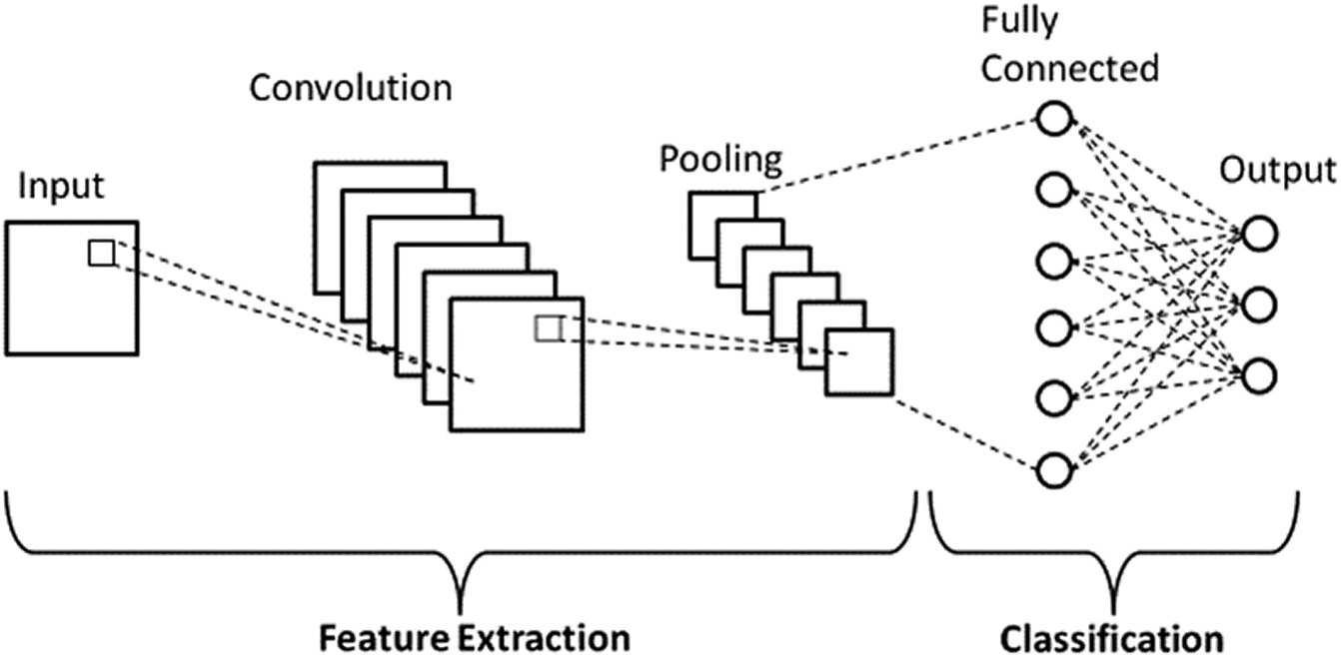
FIGURE 8.3
Architecture of custom CNN.

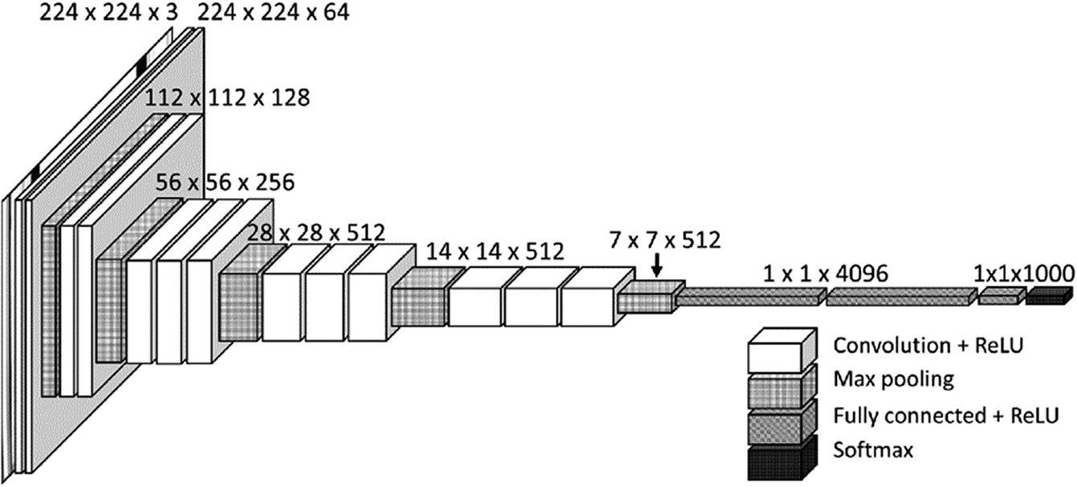

FIGURE 8.4
Architecture of VGG16.

      - ResNet-50
ResNet (residual network), proposed by Kaiming et al. in the year 2015, is a 50-layer CNN with 48 convolution layers, 1 max-pool layer, and 1 aver- age pool layer [18]. The architecture of Resnet-50 is shown in Figure 8.5. The input size of 180 × 180 is passed to the 50 layers of the network [19].

      - InceptionV3
Inception v3 is proposed by Szegedy et al. in the year 2015 [20]. The incep- tion V3 contains 5 convolution layers, 2 max-pooling layers, 11 inception modules, 1 average pooling layer, and 1 dense layer [21]. The architecture of Inception V3 is shown in Figure 8.6. The input size of 229 × 229 is passed to the 48 layers of the network.

Dataset
The dataset for this study was collected from the dataset repository Kaggle under the title “Kashmir Apple Leaf Disease” [22]. The data set contains 419 images of infected and healthy leaves. Table 8.2 contains the number of images for individual classes.

Data Augmentation
Data augmentation is a technique by which artificial data is generated from the dataset in order to decrease overfitting during the training of a model. In augmentation, geometric and color space transformations

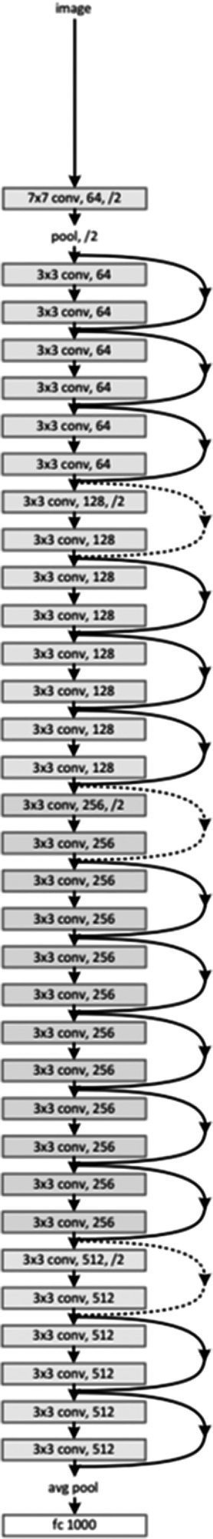

FIGURE 8.5
Architecture ResNet-50.

Using Deep Learning to Detect Apple Leaf Disease • 151

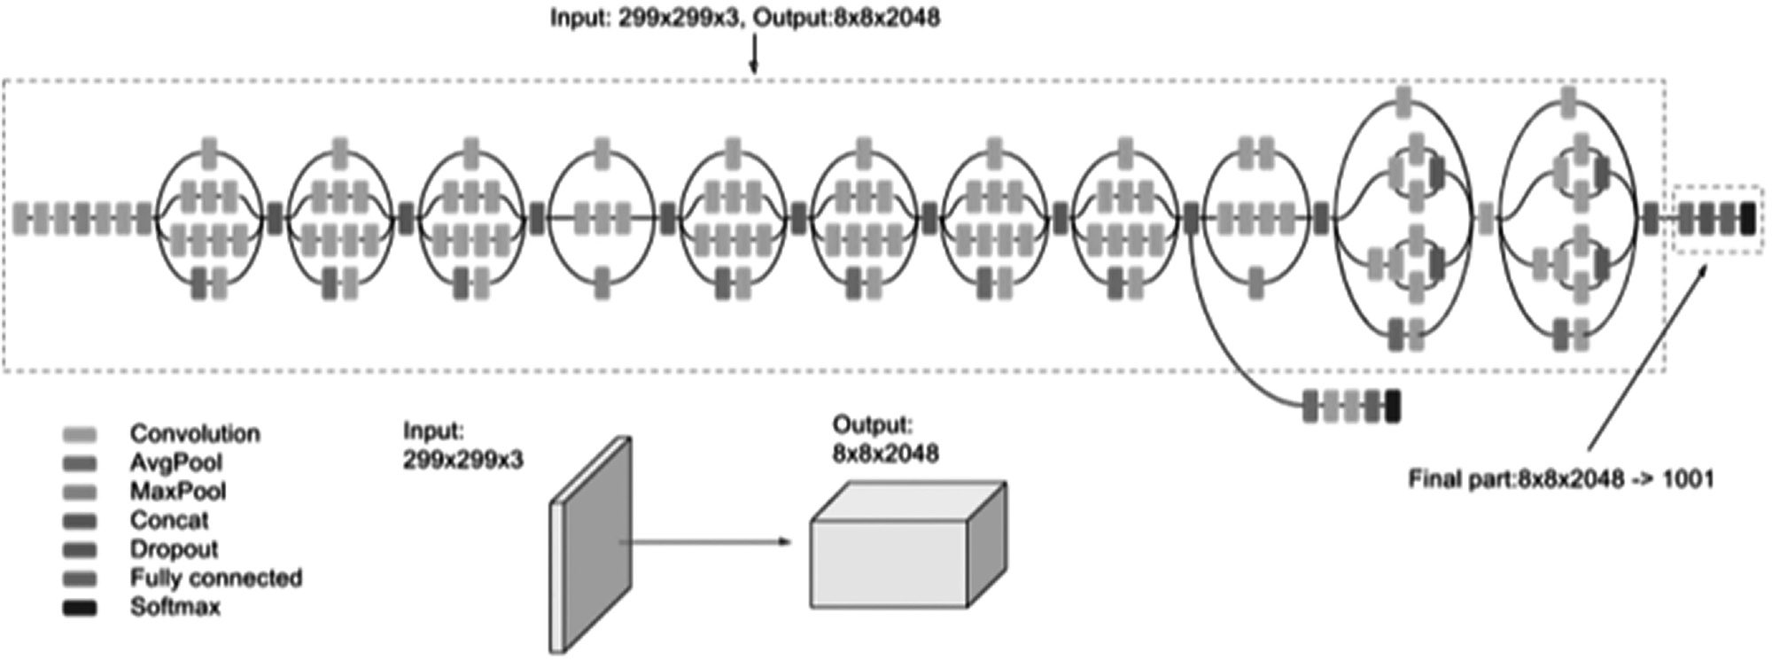

FIGURE 8.6
Architecture of inception V3.

TABLE 8.2
Number of Records in Dataset

Class

Total Number of Images

Healthy 46
Apple Rot 103
Alternaria leaf Blotch 111
Apple Scab 159

(flipping, resizing, cropping, brightness, and contrast) are used [23]. In this study, 419 image files of the dataset have been augmented to generate 2,000 files.

Experimental Environment
Coding for experimentation is performed within a Python environment called Google Colab – a product developed by Google Research. It enables the writing and execution of code directly through a web browser [24].

MODEL EVALUATION
Model evaluation refers to the methodology of evaluating the model’s per- formance. Several evaluation parameters are used for that purpose that are all based on the following outcomes of classification predictions: True Negative (TN), True Positive (TP), False Positive (FP), and False Negative (FN). Conventional performance evaluation parameters are accuracy, pre- cision, recall, and F1-score [25].

- Accuracy: The proportion of predictions classified correctly by the model.

Acc = TN + TP TN + TP + FP + FN

(8.6)

- Precision: The ratio of positive values classified correctly to all the positives.

TABLE 8.3
Evaluation Parameters
Algorithm | Classification Accuracy (%) | Precision | Recall | F1-Score
Custom CNN | 80 | 0.78 | 0.77 | 0.77
VGG16 | 85 | 0.82 | 0.81 | 0.81
ResNet-50 | 81 | 0.79 | 0.77 | 0.78
InceptionV3 | 0.83 | 0.80 | 0.78 | 0.79

Precision = TP
TP + FP

(8.7)

- Recall: The ratio of correctly classified positive values to the total positives in a class.

Recall = TP
TP + FN

(8.8)

- F1-score: Harmonic mean (weighted average) of values given returned by recall and precision.

F1− score = 2 ∗( Precision∗Recall)
Precision + Recall

(8.9)

The values of performance evaluation parameters for all the models are represented in Table 8.3.

RESULTS
In the current study, four different models – custom CNN, VGG16, ResNet-50, and InceptionV3 – were employed for predicting and classi- fying apple leaf diseases. The performance metrics, including classifica- tion accuracy, precision, recall, and F1-score, were used to evaluate the models [26–30]. Among these models, VGG16 emerged as the top per- former, exhibiting an impressive accuracy of 85%. The precision, recall,

and F1-score for VGG16 were also commendable, with values of 0.82, 0.81, and 0.81, respectively. The values of the performance parameters of all the models are shown in Table 8.3. This suggests that VGG16 excelled in correctly identifying and categorizing apple leaf diseases, showcasing its potential for practical implementation in disease detection systems for apple orchards.
Furthermore, the comparative analysis of the models highlight the sig- nificance of choosing an appropriate deep-learning architecture. While custom CNN, ResNet-50, and InceptionV3 demonstrated respectable per- formance, VGG16 consistently outperformed them across all evaluation metrics. The robustness of VGG16 in handling the complexities of apple leaf images and accurately predicting diseases underscores its suitability for real-world applications. These results not only validate the effective- ness of deep learning in disease prediction but also emphasize the impor- tance of model selection, with VGG16 standing out as the most reliable and accurate choice for the detection of apple leaf diseases in the context of Kashmir’s orchards.

CONCLUSION
At the beginning of this chapter, the advancements of machine learn- ing and deep learning and the purpose of this study were discussed. The next segment was about the work done in this regard. Following that, the experiment setup was discussed, which comprised the dataset, steps fol- lowed, and models [31–35]. The last section is about the results of the mod- els performed using various performance evaluation parameters.
This study presents a significant advancement in the field of agriculture, specifically addressing the challenges faced by apple cultivators in Kashmir. The proposed deep learning–based system, utilizing custom CNN, VGG16, ResNet-50, and InceptionV3 models, exhibits a commend- able accuracy of 85%, with VGG16 leading in performance. The classifica- tion of apple leaves into distinct categories – healthy, apple rot, Alternaria leaf blotch, and apple scab – proves to be an invaluable contribution to the farming community. The study not only offers an efficient and cost- effective alternative to traditional disease prediction methods but also sig- nifies a paradigm shift toward leveraging advanced technologies for agricultural sustainability.

Looking forward, the future of this study lies in continuous refinement and expansion. Optimization of existing models, exploration of ensemble techniques, and incorporation of real-time data sources could further enhance the accuracy and applicability of the predictive system. Extending the scope beyond apple leaves to encompass a broader range of crops would amplify the impact of these models in diverse agricultural contexts. Collaborative efforts involving experts in agriculture, data science, and technology innovation could drive interdisciplinary research, fostering innovative solutions for crop disease management. The integration of Internet of Things (IoT) devices, sensors, and big data analytics holds promise for proactive disease control strategies, ensuring the resilience and prosperity of farming communities. This study marks a pivotal step toward the integration of cutting-edge technologies in agriculture, with far-reaching implications for the future of sustainable and technology- driven farming practices.

REFERENCES
- A. Cornille, P. Gladieux, M. J. M. Smulders, I. Roldán-Ruiz, F. Laurens, B. le Cam,
A. Nersesyan, J. Clavel, M. Olonova, L. Feugey, I. Gabrielyan, X. G. Zhang, M. I. Tenaillon, and T. Giraud. New Insight into the History of Domesticated Apple: Secondary Contribution of the European Wild Apple to the Genome of Cultivated Varieties. PLoS Genetics, 8(5): e1002703, 2012. doi: 10.1371/journal.pgen.1002703
- Apple Industry in J&K A Tumbling Sector – The Kashmir Horizon. (n.d.). Retrieved January 22, 2023, from https://thekashmirhorizon.com/2022/09/27/apple-industry- in-jk-a-tumbling-sector/
- Z. Chuanlei, Z. Shanwen, Y. Jucheng, S. Yancui, and C. Jia. Apple Leaf Disease Identification Using Genetic Algorithm and Correlation Based Feature Selection Method. International Journal of Agricultural and Biological Engineering, 10(2): 74–83, 2017.
- S. R. Dubey and A. S. Jalal. Detection and Classification of Apple Fruit Diseases Using Complete Local Binary Patterns. In 2012 Third International Conference on Computer and Communication Technology, Allahabad, India, 2012, pp. 346–351. doi: 10.1109/ ICCCT.2012.76
- S. Arivazhagan, R. N. Shebiah, S. Ananthi, and S. V. Varthini. Detection of Unhealthy Region of Plant Leaves and Classification of Plant Leaf Diseases Using Texture Features. Agricultural Engineering International: CIGR Journal, 15(1): 211–217, 2013.
- M. Brahimi, K. Boukhalfa, and A. Moussaoui. Deep Learning for Tomato Diseases: Classification and Symptoms Visualization. Applied Artificial Intelligence, 31(4): 299–315, 2017. doi: 10.1080/08839514.2017.1315516
- A. I. Khan, S. M. K. Quadri, and S. Banday. Deep Learning for Apple Diseases: Classification and Identification. International Journal of Computational Intelligence Studies, 10(1): 1–12, 2021.

- M. Jan and H. Ahmad. Image Features Based Intelligent Apple Disease Prediction System: Machine Learning Based Apple Disease Prediction System. International Journal of Agricultural and Environmental Information Systems (IJAEIS), 11(3): 31– 47, 2020.
- V. A. Kherdekar Convolution Neural Network Model for Recognition of Speech for Words used in Mathematical Expression. Turkish Journal of Computer And Mathematics Education, 12(6): 4034–4042, 2021.
- R. Prasath, M. Anand, and S. Hariharan. Image Classification Using Convolutional Neural Networks. (n.d.). Retrieved from http://www.acadpubl.eu/hub/
- Q. Li, W. Cai, X. Wang, Y. Zhou, D. D. Feng, and M. Chen. Medical Image Classification with Convolutional Neural Network. In 2014 13th International Conference on Control Automation Robotics and Vision, ICARCV 2014, 2014, pp. 844–848. doi: 10.1109/ICARCV.2014.7064414
- Importance of Neural Network Bias and How to Add It. n.d. Retrieved March 3, 2023, from https://www.turing.com/kb/necessity-of-bias-in-neural-networks
- ReLU Activation Function Explained | Built In. n.d. Retrieved March 3, 2023, from https://builtin.com/machine-learning/relu-activation-function
- Comprehensive Guide to Different Pooling Layers in Deep Learning. n.d. Retrieved March 3, 2023, from https://analyticsindiamag.com/comprehensive-guide-to- different-pooling-layers-in-deep-learning/
- Softmax Activation Function: Everything You Need to Know|Pinecone. n.d. Retrieved March 3, 2023, from https://www.pinecone.io/learn/softmax-activation/
- Understanding VGG16: Concepts, Architecture, and Performance. n.d. Retrieved January 24, 2023, from https://datagen.tech/guides/computer-vision/vgg16/
- The Architecture of the VGG-16 CNN Model [26].|Download Scientific Diagram.
n.d. Retrieved January 24, 2023, from https://www.researchgate.net/figure/ The-architecture-of-the-VGG-16-CNN-model-26_fig5_326349019
- ResNet-50: The Basics and a Quick Tutorial. n.d. Retrieved January 24, 2023, from https://datagen.tech/guides/computer-vision/resnet-50/
- ResNet50_From_Scratch_Tensorflow | This Repository Implements the Basic Building Blocks of Deep Residual Networks Which Is Trained on SIGNS Dataset to Detect Numbers On Hand] Images. n.d. Retrieved January 24, 2023, from https://jananisbabu. github.io/ResNet50_From_Scratch_Tensorflow/
- Inception-v3 Explained|Papers with Code. n.d. Retrieved January 24, 2023, from https://paperswithcode.com/method/inception-v3
- C. Szegedy, V. Vanhoucke, S. Ioffe, and J. Shlens.Rethinking the Inception Architecture for Computer Vision. n.d.
- Kashmiri Apple Plant Disease Dataset | Kaggle. n.d. Retrieved January 23, 2023, from https://www.kaggle.com/datasets/hsmcaju/d-kap
- Johnson, M. n.d. What Is Data Augmentation in a CNN? Python Examples. Retrieved March 3, 2023, from https://nnart.org/what-is-data-augmentation-in-a-cnn/
- Welcome to Colaboratory - Colaboratory. n.d. Retrieved January 23, 2023, from https://colab.research.google.com/
- M. Hossin, and M. N. Sulaiman. A Review on Evaluation Metrics for Data Classification Evaluations. International Journal of Data Mining & Knowledge Management Process, 5(2): 01–11, 2015. doi: 10.5121/ijdkp.2015.5201

- S. N. H. Bukhari, J. Webber, and A. Mehbodniya. Decision Tree Based Ensemble Machine Learning Model for the Prediction of Zika Virus T-Cell Epitopes as Potential Vaccine Candidates. Scientific Reports, 12: 7810, 2022. doi: 10.1038/ s41598-022-11731-6
- G. S. Raghavendra, S. Shyni Carmel Mary, P. B. Acharjee, V. L. Varun, S. N. H. Bukhari, C. Dutta, and I. A. Samori. An Empirical Investigation in Analysing the Critical Factors of Artificial Intelligence in Influencing the Food Processing Industry: A Multivariate Analysis of Variance (MANOVA) Approach. Journal of Food Quality, 2022, Article ID 2197717, 7 pages, 2022. doi: 10.1155/2022/2197717
- S. N. H. Bukhari, A. Jain, E. Haq, A. Mehbodniya, and J. Webber. Ensemble Machine Learning Model to Predict SARS-CoV-2 T-Cell Epitopes as Potential Vaccine Targets.
Diagnostics, 11(11): 1990, 2021. MDPI AG. doi: 10.3390/diagnostics11111990
- S. L. Bangare, D. Virmani, G. R. Karetla, P. Chaudhary, H. Kaur, S. N. H. Bukhari, and S. Miah. Forecasting the Applied Deep Learning Tools in Enhancing Food Quality for Heart Related Diseases Effectively: A Study Using Structural Equation Model Analysis. Journal of Food Quality, 2022, Article ID 6987569, 8 pages, 2022. doi: 10.1155/2022/6987569
- C. M. Anoruo, S. N. H. Bukhari, and O. K. Nwofor. Modeling and Spatial Characterization of Aerosols at Middle East AERONET Stations. Theoretical and Applied Climatology, 152: 617–625, 2023. doi: 10.1007/s00704-023-04384-6
- F. Masoodi, M. Quasim, S. Bukhari, S. Dixit, and S. Alam. Applications of Machine Learning and Deep Learning on Biological Data. CRC Press, 2023.
- S. N. H. Bukhari, A. Jain, and E. Haq. A Novel Ensemble Machine Learning Model for Prediction of Zika Virus T-Cell Epitopes. In Gupta, D., Polkowski, Z., Khanna, A., Bhattacharyya, S., and Castillo, O. (eds) Proceedings of Data Analytics and Management. Lecture Notes on Data Engineering and Communications Technologies, vol. 91. Springer, Singapore, 2022. doi: 10.1007/978-981-16-6285-0_23
- S. N. H. Bukhari, F. Masoodi, M. A. Dar, N. I. Wani, A. Sajad, and G. Hussain. Prediction of Erythemato-Squamous Diseases Using Machine Learning. In Auerbach Publications eBooks, pp. 87–96, 2023. doi: 10.1201/9781003328780-6
- S. N. H. Bukhari, A. Jain, E. Haq, A. Mehbodniya, and J. Webber. Machine Learning Techniques for the Prediction of B-Cell and T-Cell Epitopes as Potential Vaccine Targets with a Specific Focus on SARS-CoV-2 Pathogen: A Review. Pathogens, 11(2): 146, 2022. MDPI AG. doi: 10.3390/pathogens11020146
- S. Nisar, H. Bukhari, and M. A. Dar. Using Random Forest to Predict T-Cell Epitopes of Dengue Virus. Adv. Appl. Math. Sci.. 20(11): 2543–2547, 2021.

